Basic Instructions

# Introduction

“Track My Mood” is a .Net app running on your laptop that measures your mood and sentiment by analysing what an user types in an active window (for example, outlook, word, notepad, but not limited to that). The user can also talk to the application instead of typing, exposing a much more natural way of interaction. Both written and spoken inputs are analysed using APIs for Text Analytics, Sentiment Analysis and Speech Recognition.

The tool analyses these input streams in real time, and tracks the user's mood from both written and spoken input. The user is in control of when this tracking happens, and can deactivate at will. None of the typed or spoken input is recorded or persisted before or after the API calls.  For registering written input, the code injects a hook via Windows API into the Operating System’s message queue to intercept input. Upon closing the program the hook is deactivated.

# Requirements

* Execute on a 64 bit machine
* Requires .Net 4.6.1 runtime - <https://www.microsoft.com/en-US/download/details.aspx?id=49981>

# Usage

Usage is easy. There is only one project, and nothing required to setup other than internet access.

Press Ctrl+F5 to execute from Visual Studio if running the source code. If not running from VS, refer to this section below.

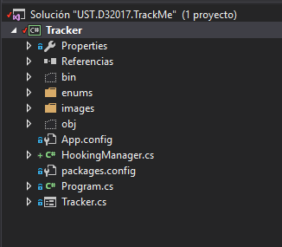

You will see this form

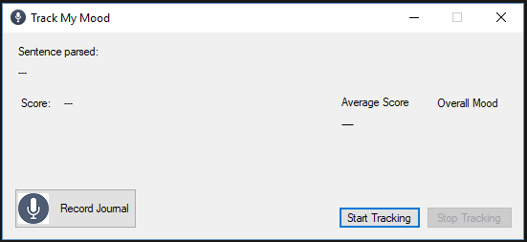

Open an application like Notepad, Outlook, Word etc.

Click start tracking

And then type something coherent in the application you choose.

I will use notepad for the screenshots here, but you can see something like a new email on outlook, or Word, etc.. When you type in a period, the sentence is sent to the cloud for parsing and sentiment analysis. You should see this:

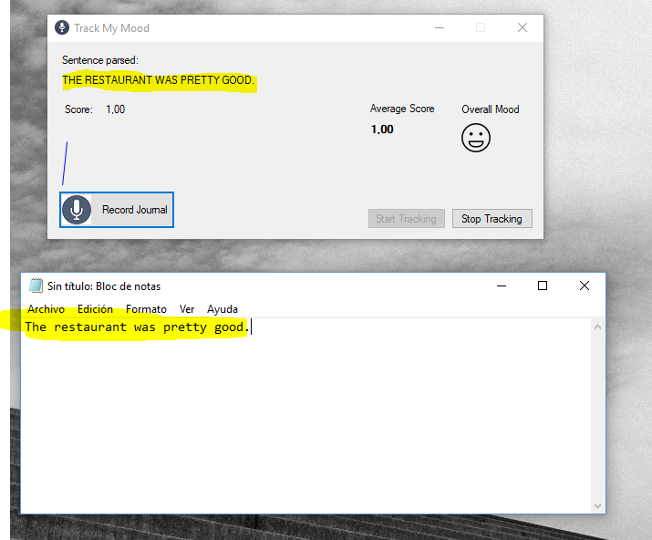

As you can see the sentence is reflected in the application and parsed. You get a score on the left for that particular sentence. On the right you get the average of all sentences typed so far and a mood indicator ( there 5 faces, from 0-20, 20 to 40 and so on).

Type something else. A you type in sentences, the average changes, and the graph reflects the point evolution. The icon changes accordingly.

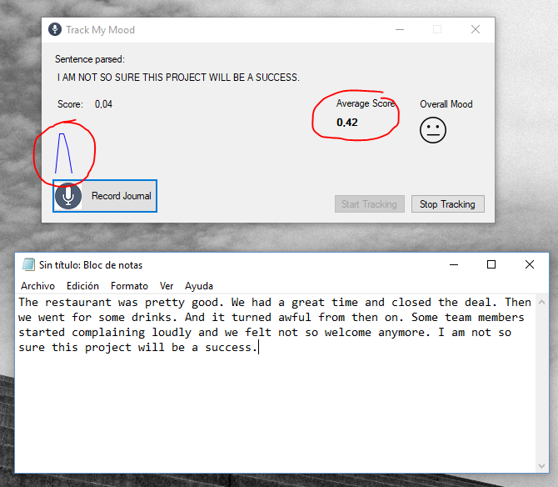

# Spoken input

You can also speak to the mic instead of typing your feelings in. The behaviour is the same. Click “Record Journal” and the application will change to this:

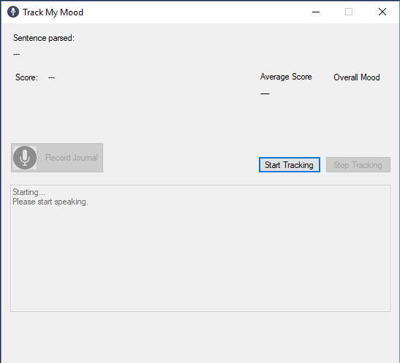

Depending on the mic quality and accent results might vary. Do not speak very fast, or far from the mic, and try to enunciate clearly for voice recognition to get the best results. Sometimes there are some funny analysis returned from the engine. Of course, a silent environment works best.

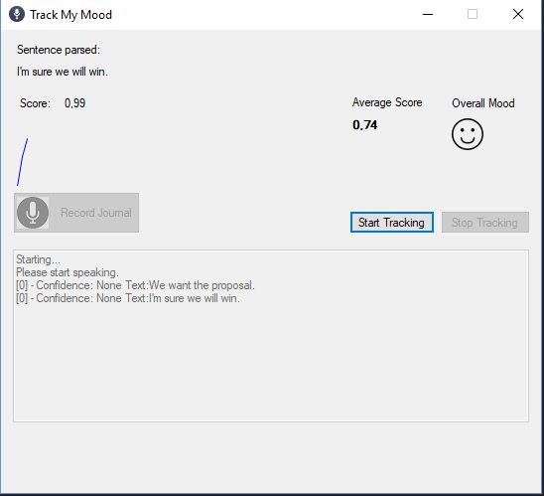

When you want to stop audio analysis, just stop speaking and after a while it will stop. There is no specific stop button.

You can combine both audio and text.

# Exit

When exiting is better to click Stop Tracking first, but anyway, on closing the form, the hook is deregistered automatically

# Executing without Visual Studio

Once the Repo has been downloaded, unzip the file inside the _release folder:

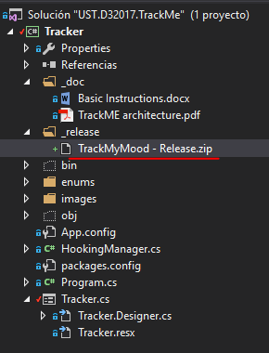

You will see this list of files, and the one that has to be run:

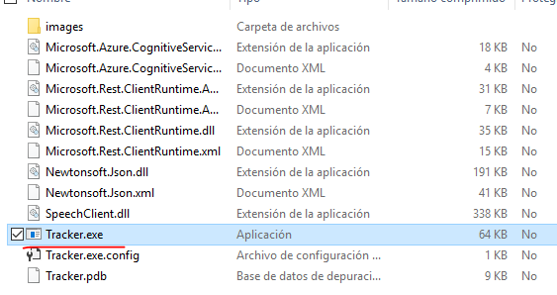

The rest is the same as explained above

# What next? Future possibilities

One idea that could be easily implemented based on this prototype is a plugin for Office, that can run in Word and Outlook and monitor what is being written, for mood and sentiment, thus giving feedback to the user before sending an email that might be perceived as negative, belligerent etc

Also, the speech recognition capability would enable dictation and feedback at the same time in several languages.

Another idea is for measuring collective mood through a dashboard. The tracking data from an entire team or organization can be channelled to a service that aggregates all the data measured for all members of a given team, so it becomes like an emotional health indicator.

I was thinking logging this data to a time-line series database like InfluxDB and creating a dashboard with Grafana for monitoring the mood of an entire team.

We could then see how mood correlates to different phases of the project, as well as detect when morale might be going down and take corrective action sooner. At the same time but at a higher level, we could aggregate data from all projects whose members track their mood into a department and/or company-wide color bar that gives indication of how the company "feels"